WORKSHOP for F2F Instruction
Module Title | Train the Trainer Pedagogies
Duration (in min/hours) | 4 hours
Workshop Objectives:
Upon completion of this Module learners should be able to:

- Reflect on the relationship among pedagogy, individuals and societies in an increasingly complex world;
- Focus on the evolution of pedagogy in the XX and XXI century;
- Identify the main characteristics of the pedagogical approaches behind Global Citizenship Education (GCE) and Sustainable Development Education (SDE)
Methodology (discussion, role-play, problem solving etc.) | Brainstorming, Discussions, Preferable Futures, Problem solving.
Materials/Equipment (projector, internet connection etc.) | Wi-fi connection, pc, projector, speakers (or an interactive board), flip-chart, flip-chart papers, markers, laptops or tablet (THE WORLD WE WANT ACTIVITY), blank papers (possibly recycled), scissors, glue, tape, old magazines, post-its, pens.
Resources
ANNEXES | Name each material you have produced, number it and include it to the ANNEX section. If you have produced material other than word documents (e.g. ppts) please refer to the name of the file and attach it together with the workshop plan to the email. You should specify to the process below when and how the material will be used during the lesson (see the example below).  My Learning Objective ANNEX 1  Formal, Non-formal and Informal Learning ANNEX 2  Multiple intelligences ANNEX 3  SDGs cards ANNEX 4  Problem tree ANNEX 5  Silhouette of the trainer ANNEX 6  Cross-cutting key competences for achieving all SDGs ANNEX 7

Detailed description of the activities that will be carried out during the lessons.
Introduction to the topic (activating students’ prior knowledge, stating learning tasks)
- Welcome participants and introduce yourself. Explain the workshop agenda (sessions and overall objectives) either showing it on the screen or on a flip chart paper. This second option is preferable as it can be sticked to the wall and participants can have a look at it whenever they feel the need;

- LEARNING OBJECTIVES. Give participants My Learning Objective Handout (Annex 1). Ask them to think about their learning objectives for the workshop by following the questions shown on the screen:
- What do I need to learn in terms of knowledge?
- What skills do I want to develop?
- What attitudes and values do I want to strengthen, which do I want to get rid of?
Participants write their learning objectives down on the left side of the chart. For the second column, they will need to look at the workshop programme and identify possible moments in which they can achieve those objectives. Encourage them to challenge themselves! The check section will be used at the end of the workshop to see if they have achieved their learning objectives.

Ask participants to share in couples some of their personal learning objectives, and in which session they think this could happen. (S)he also asks participants to share in plenary with the group the attitudes and values they want to strengthen.

Point out that those spotted by them are the cognitive, socio-emotional and behavioural learning objectives that learners approaching sustainable development education and global citizenship education develop.

SUGGESTED DURATION: 20 minutes in total

- LIFE MAP. Ask learners to think about their life and to identify the moments in which they learnt something from someone (it can be anywhere: in school, on the street, with a friend, at work, etc.). What happened in those situations? Who were these people? What did they do? How did they behave? How did they help you? Your life map can look like a timeline (since when you were born or it may start from any moment in your life), as a normal map with footsteps, continents or can be a collection of pictures (Readapted by ACUMEN online course “Storytelling for Change”).

Ask 2 or 3 of them to share one moment briefly with the others

Underline that we can learn in several moments, from different people and in distinct contexts. Learning offers us the chance to use, expand and train our reason and imagination to survive and constantly improve our conditions, solving problems, visualizing alternative solutions and progressing.
Here you can find the definition of formal, non-formal and informal education adapted from the North South Center of the Council of Europe that has always worked to strengthen the overall work on Global Citizenship Education and empower young people all over the world.

Show them Annex 2 on formal, non-formal and informal learning.

Topic Exploration (Knowledge construction)
- THE WORLD WE WANT: Divide participants into groups of maximum 5 people, each of which should explore one of the topics proposed according to a specific intelligence, taken from Howard Gardner’s Multiple Intelligences Theory.

Ask them if they know about this theory. If some of the participants know it, then let them explain, otherwise you can use this video (https://www.youtube.com/watch?v=UHMzELRpLr0, each country to find the most suitable video about multiple intelligences in their language).

Explain that they will need to choose one among these 4 intelligences (linguistic, musical, visual and kinesthetic) to explore one of the following topics. You can help them by showing on the screen Annex 3, Multiple intelligences description.

Topics:
THE WORLD WE WANT
GLOBAL AND LOCAL CONNECTIONS
BEYOND POVERTY

To make sure participant work from a SDGs perspective, distribute to each group the SDGs cards (Annex 4).
Give participants 20 minutes to choose one of these topics and to work upon it, sharing visions, comments, experiences they have lived so far, in order to build a 3 minute work that will be shared in plenary at the end of the activity. Put at their disposal some materials, like: laptops, blank papers (possibly recycled), scissors, glue, tape, old magazines.

DEBRIEFING: Specific questions can be made about the dynamics, decisional processes and leadership. Was it easy to work together with the focus on a specific intelligence? Do you think there is a link among the different presentations in terms of contents and priorities to tackle? Why do you think it is important to envision preferable futures?

Make participants notice that Multiple Intelligences are part of the pedagogy activism that put learners at the center of the learning process, XX century. How can we ensure we create inclusive activities when running SDE and GCE activities? By giving learners very differentiated materials (pictures, videos, texts, manual activities etc.). As educators, make sure you keep the learner-centered approach in mind from the research moment (as Freire would call it), the moment in which the educator prepares the learning sessions. As for preferable futures, remind them about this (on the PPT and online course):

Preferable futures: According to Freire, when confronted with issues that are relevant to learners, centered in their realties and have a direct impact on their daily life, learners are naturally inclined to imagine alternative, preferable futures. This possibility is offered by a dynamic present in which different choices and actions can lead us to different consequences, hence different futures. “Anticipating and planning skills, desirable, preferable and hoped futures” train imagination and open up a space for change, for improvement towards a more sustainable and just society. In fact, it is fundamental to “be aware that solidarity towards future generations is one of the key elements of sustainability together with being able to differentiate probable futures from desirable, preferable and sustainable ones”.

SUGGESTED DURATION: 45 minutes in total

- GLOBAL AND LOCAL APPROACHES AND ISSUES: Show this warm-up video
What is sustainable development - SDGS https://www.youtube.com/watch?v=3WODX8fyRHA

Explain participants that we are now going to carry out “Stand UP! Interviews. ACTORS for change”: ask them to present up to 3 main issues and needs related to SDGs that are a priority for their local context talking no stop for 1 minute, simulating an interview or an elevator pitch. Be strict on timekeeping, allowing them to speak no more than 1 minute. Give them 5 minutes for preparation.

On a flipchart, note the issues named by participants during their interviews and tell them that they will be the roots of our “Problem Tree”.

Problem Tree: On flip-chart papers, draw a big trees for participants to work on them in groups (each group needs to have 1 tree). In each flip chart sheet, we draw a big tree (trees will be spread around the room with different goals picked from the SDGs - see below). Each tree has different goals on it, so that each group will work on a different macro-topic. Let’s imagine we have 4 goups: each group receives one problem tree with one of these macro-topics:
- Basic human needs: SDG 1,2,3,4
- Environment: SDG 7,13,14,15
- Economic growth: SDG 8,9,10,11,12
- Peace and justice: SDG 16

The problem tree is composed this way: The trunk is represented by the macro-topic. The roots are the issues identified in local realities and noted down on the flip-chart paper by the trainer. Participants can decide to re-write them on their tree or not. The leaves represent the actions that participants take or could take in everyday life at local level to solve the problem and achieve the different goals, so they have to reflect on the causes (roots) and solutions (leaves) under the lenses of their macro-topics and the SDGs related to it. Give each group 20 minutes approximately.

Ask participants to take some post-its and a marker or a pen and move freely in the room and find post-its on the trees to write actions they take in everyday life at local level that are achieving that goal and that are not written on the tree.

While participants are running the activities, the trainer needs to go around and take notes of the solutions proposed, trying to cluster them. Share your reflections with participants.

DEBRIEFING:
- How was the Stand Up interview?
- Was it easy to relate your realities with the global context in 1 minute?
- What did you learn? (contents, public speaking, facilitation, SDGs..)

Underline the complexity dimension and the local and global connections. Remind participants that “As a result of many ties of interdependence among countries, the world we live in has evolved into a globalised system. Recent history unquestionably shows that the lives of the men and women of this planet may be affected by events and processes thousands of kilometres away. World-wide economic, geopolitical and social relations, modern communications and technologies, media and transport allow a fast flow of information. People and goods are both causes and characteristics of globalisation as a process that leads to an interdependent world and to what nowadays is called glocalisation.”
(Global Education Guidelines, Council of Europe, 2012) – Taken from the PPT and online course.

ESTIMATED DURATION: 45 minutes in total

INTERMEDIATE REFLECTION MOMENT 1:
- Before going to the next activity, invite participants to go back to their Learning Objective Handout and review them (they can add, update them, etc.).
- In plenary, discuss the following questions:
- What knowledge do SDE and GCE develop?
- What skills do SDE and GCE develop?
- What values do SDE and GCE develop?
- In which contexts can we apply SDE and GCE methodology?

ESTIMATED DURATION: 20 minutes

- WHAT IT TAKES TO BE AN SDE AND GCE TRAINER: Show participants the silhouette of the trainer represented in Annex 6: you can print it at least in A3 dimensions or draw it on a flip-chart paper. In this silhouette participants can see the brain, the mouth, the hart and the hands

Give each participants 8 post its each maximum (possibly of different colors, 2 post-its for each colour). Each post-it will be stick next to the brain (knowledge), mouth (communication), heart (values and attitudes) and hands (skills and tools) for a maximum of 2 post-its for each participant on each category. Ask them to write individually on each post it the main fundamental characteristics of the trainer for each category and to stick them on the silhouette.

Cluster the post-its, share the outcomes with participants and open the floor for reflections.

DEBRIEFING:
- Does a trainer with those features exist?
- Which are the minimum competences of a SDE and GCE trainer?
- How can we overcome the fact that a person might not have all those competences at the same time?

Make sure you cover the following points (on the PPT and online course): The role of the trainer is essential for a successful implementation of the transformative approach common to SDE and GCE.
Trainers as facilitators: From the very beginning, trainers must challenge their thinking and act as facilitators, guiding the process and fading to give the real protagonism to the learners.

While preparing the didactic and the material, trainers need to conduct a research to identify the topic, the methodology and the method that better suits their students’ needs and curiosity. This topic could be suggested by the learners, co-developed or at least be something that learners think is relevant to them and by which they feel motivated

Since the issues that are tackled are complex and multi-faceted, trainers could play different roles to keep the discussion going and promote critical thinking, as Oxfam points out in Teaching Controversial Issues.

The six roles are:
1. Committed The trainer is free to share their own views for young people to challenge, making it clear that this role could lead to biased discussion.
2. Objective or Academic The trainer gives an explanation of all possible viewpoints without stating their own position.
3. Devil’s Advocate The trainer deliberately adopts an opposite stance irrespective of their own viewpoint. This approach helps ensure all views are covered and challenges existing beliefs.
4. Advocate The trainer presents all available viewpoints then concludes by stating own position with reasons.
5. Impartial Chairperson The trainer ensures that all viewpoints are represented, through young people’s statements or published sources. Trainer facilitates but does not state their own position.
6. Declared Interest The trainer declares their own viewpoint so that young people can judge later bias, then presents all positions as objectively as possible.

At the same time, it is important for trainers to become observers when interaction among learners is happening and to give them the space to re-orientate themselves and develop their own learning priorities and to construct their own meaning throughput the Learn-Think-Act learning process.

Trainers-facilitators need to have advanced communication competences. In fact, as Watzlawick and other psychologists from the Palo Alto tradition pointed out, interpersonal communication plays a fundamental role on successful and effective educational and learning processes. Trainers-facilitators must suspend judgement, listen actively, be empathic and support their learners to establish a shared learning process where they enhance the development of the cognitive, socio-emotional and behavioural competences.

ESTIMATED DURATION: 40 minutes

INTERMEDIATE REFLECTION MOMENT 2:
- Show participant the video “Changing education paradigms” https://www.youtube.com/watch?v=zDZFcDGpL4U
What do you think about the video?
What are your reflections right now?
What can you do to change the education paradigms?

ESTIMATED DURATION: 20 minutes

- FINAL WRAP UP: Ask learners to go back to their Learning Outcomes Handout and review it according to the agenda. One by one, show the cross-cutting key competences for achieving all SDGs: In which session of the agenda did they develop those competences? Use Annex 7 to go through them.

For each competence, ask maximum 2 people to share their reflections with the other participants.

End this workshop reminding about the importance of bringing Sustainable Development and Global Citizenship in formal and non- formal education:
When preparing your methods to talk about sustainable development and global citizenship, always keep in mind the transversal key competencies for achieving a sustainable future where young people play and active, leading and change-making role. We have chosen the ones proposed by UNESCO in their Education for Sustainable Development Goals - Learning Objectives for the SDGs (2017) that also guide SDG 4, Target 7:
By 2030, ensure that all learners acquire the knowledge and skills needed to promote sustainable development, including, among others, through education for sustainable development and sustainable lifestyles, human rights, gender equality, promotion of a culture of peace and non-violence, global citizenship and appreciation of cultural diversity and of culture’s contribution to sustainable development

Remind them that teachers and trainers, together with decision makers, CSOs and young sustainability change makers are at the main actors that will make change possible.

ESTIMATED DURATION: 30 minutes

Reflection/Feedback (on the content, the activities etc.)
Each activity proposed is participatory and foresees “real time” feedback. Furthermore, for each method there is a debriefing moment and 2 intermediate reflection moments have been identified to fix knowledge, deepen reflections and share views, opinions and experiences.

Assessment (how you will ensure that participants have learned)
A pre, during and post self-assessment is proposed through the Learning Objectives Handout.

ANNEX 1
Learning objective | This is how I'll do it! | Check!

ANNEX 2
Formal learning… | Non formal learning… | Informal learning…
Is promoted by educational systems (schools, universities etc.) | Takes place outside formal learning environments (community, NGOs, associations, etc.) | Takes place outside schools and colleges (in a family, on the street, among friends etc.)
Follows a syllabus | Does not follow a formal syllabus but is based on an organisational framework | It does not have any organizational structure as it arises from the learner’s involvement in activities that are not undertaken with a learning purpose in mind. Learning that is formal or non-formal is partly intentional and partly incidental: when we consciously pursue any learning target we cannot help learning things that are not part of that target. Informal learning, however, is exclusively incidental.
Is intentional in the sense that learning is the goal of all the activities learners engage in | Arises from the learner’s conscious decision to master a particular activity, skill or area of knowledge and is thus the result of intentional effort | Informal learning is involuntary, exclusively incidental and an inescapable part of daily life; for that reason, it is sometimes called experiential learning.
Learning outcomes are measured by tests and other forms of assessment | Is not governed by external accreditation and assessment | Learning outcomes are not tested or measured
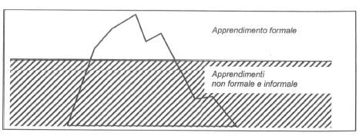
ANNEX 3
Visual-Spatial - think in terms of physical space, as do architects and sailors. Very aware of their environments. They like to draw, do jigsaw puzzles, read maps, daydream. They can be taught through drawings, verbal and physical imagery. Tools include models, graphics, charts, photographs, drawings, 3-D modeling, video, videoconferencing, television, multimedia, texts with pictures/charts/graphs.
Bodily-kinesthetic - use the body effectively, like a dancer or a surgeon. Keen sense of body awareness. They like movement, making things, touching. They communicate well through body language and be taught through physical activity, hands-on learning, acting out, role playing. Tools include equipment and real objects.
Musical - show sensitivity to rhythm and sound. They love music, but they are also sensitive to sounds in their environments. They may study better with music in the background. They can be taught by turning lessons into lyrics, speaking rhythmically, tapping out time. Tools include musical instruments, music, radio, multimedia.
Linguistic - using words effectively. These learners have highly developed auditory skills and often think in words. They like reading, playing word games, making up poetry or stories. They can be taught by encouraging them to say and see words, read books together. Tools include computers, games, multimedia, books, tape recorders, and lecture.

ANNEX 4
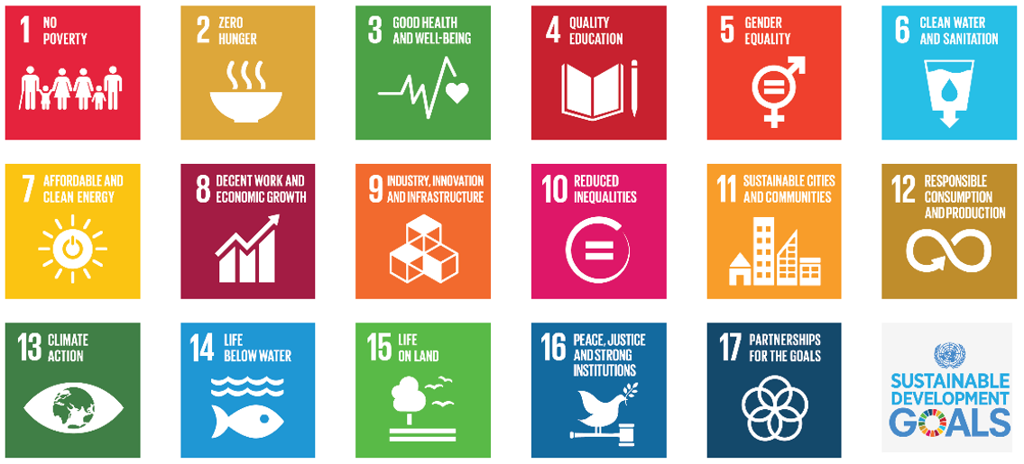

ANNEX 5

ANNEX 6
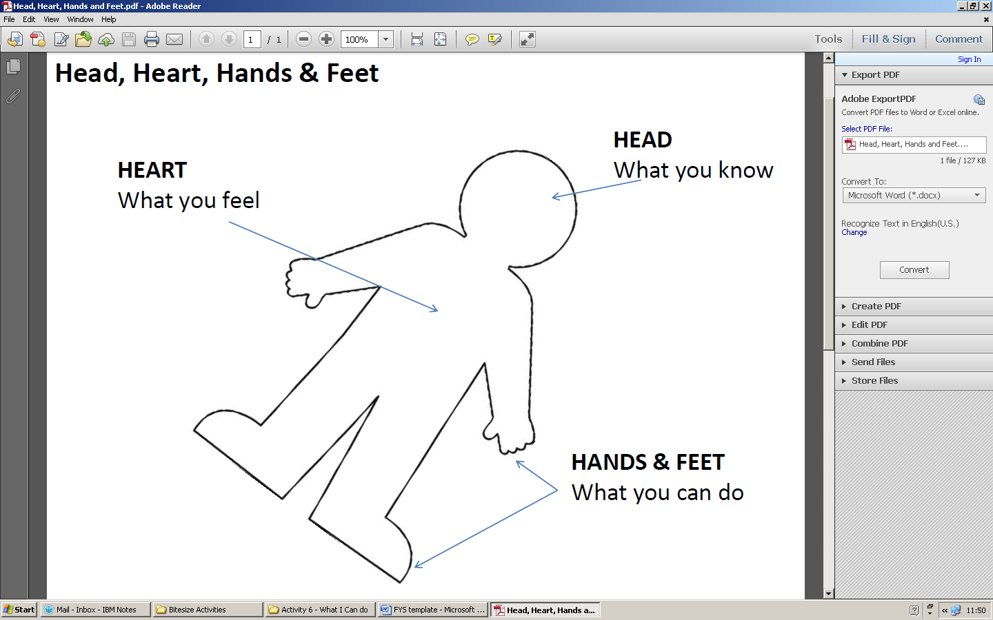

ANNEX 7
Systems thinking competency: the abilities to recognize and understand relationships; to analyse complex systems; to think of how systems are embedded within different domains and different scales; and to deal with uncertainty.
Anticipatory competency: the abilities to understand and evaluate multiple futures – possible, probable and desirable; to create one’s own visions for the future; to apply the precautionary principle; to assess the consequences of actions; and to deal with risks and changes.
Normative competency: the abilities to understand and reflect on the norms and values that underlie one’s actions; and to negotiate sustainability values, principles, goals, and targets, in a context of conflicts of interests and trade-offs, uncertain knowledge and contradictions.
Strategic competency: the abilities to collectively develop and implement innovative actions that further sustainability at the local level and further afield.
Collaboration competency: the abilities to learn from others; to understand and respect the needs, perspectives and actions of others (empathy); to understand, relate to and be sensitive to others (empathic leadership); to deal with conflicts in a group; and to facilitate collaborative and participatory problem solving.
Critical thinking competency: the ability to question norms, practices and opinions; to reflect on own one’s values, perceptions and actions; and to take a position in the sustainability discourse.
Self-awareness competency: the ability to reflect on one’s own role in the local community and (global) society; to continually evaluate and further motivate one’s actions; and to deal with one’s feelings and desires.
Integrated problem-solving competency: the overarching ability to apply different problem-solving frameworks to complex sustainability problems and develop viable, inclusive and equitable solution options that promote sustainable development, integrating the abovementioned competences.

